Saturday, March 16
Today has been one of the longest days of my life. Yesterday, we got on the plane to Paris, and I didn't manage to sleep very much. I had my eyes closed for probably 4 or 5 hours, so that helped a bit. But we landed and went straight to the hotel to get unpacked. Afterwards, we went to explore the area for a bit and get something to eat. I went with Olivia, Molly, Lisa, Amanda, and Michelle to the Monoprix up the street to take a look around, and I found Kinder eggs!! Hopefully I can find a way to bring those home for Easter... they'll probably be ruined in the checked baggage. But maybe my semester in packaging will come in handy! We'll see. Then, we joined everyone else at a café, where I had the most expensive coffee of my life (4,8 euros) and a delicious crepe with butter and sugar.

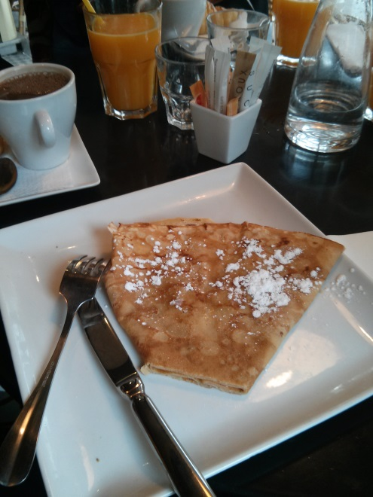

We went back to the hotel for a bit before going to see the Marais, beginning with the Opera Bastille.

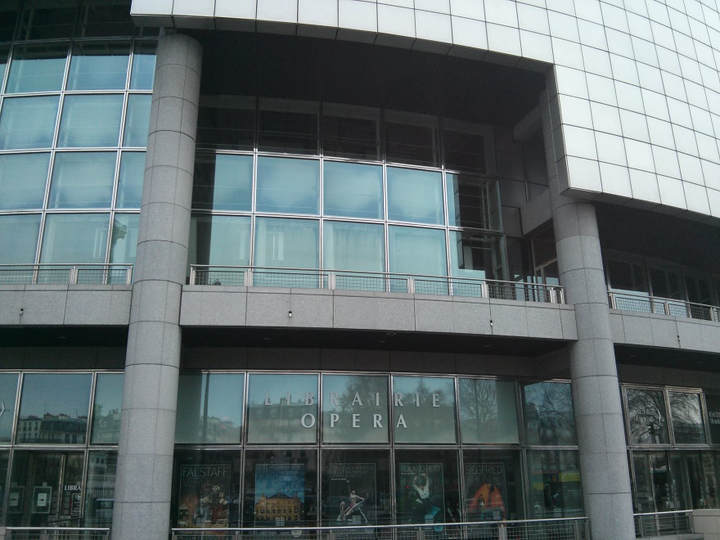

Next, we went to Place des Vosges and saw Victor Hugo's house and museum. I loved the arches on all of the buildings surrounding the Place des Vosges. It was really a beautiful park. And, as it turns out, they have the exact same jungle gym as in Crescent Park in Wyoming!

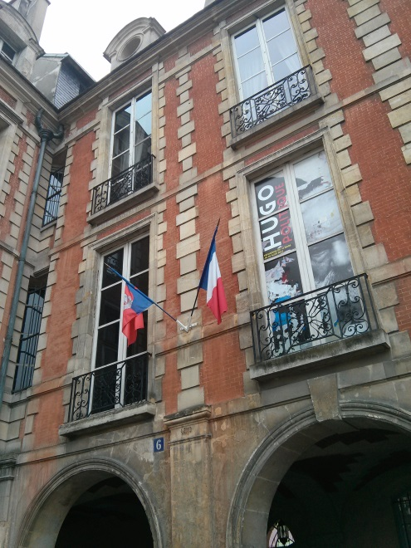

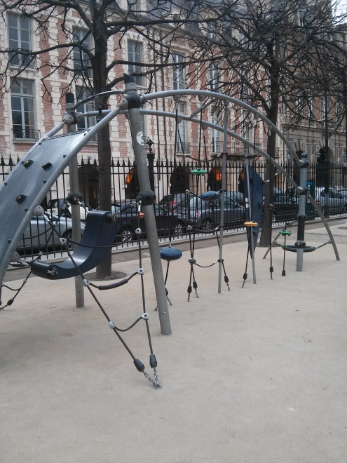

Next, we went to the Carnavalet museum to see the history of Paris, which was very beautiful, but also very very large. It never seemed to end. We went to the bookstore and I saw a book called "Paris at your feet" and it was all pictures of the things you find on the ground in Paris, like old railway tracks. I'll have to see if I can track that book down again.

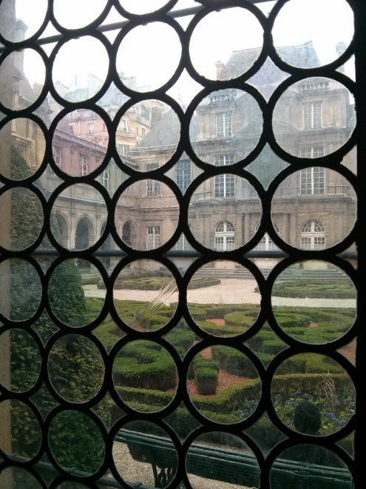

After that, we went to the Arc de Triomphe and climbed all the way up the grueling staircase to reach the top and see an incredible view of Paris. We took so so soooo many pictures by the Eiffel Tower. From the Arc, the Eiffel Tower actually looks pretty small, even though it's massive. It must've been a trick of perspective.

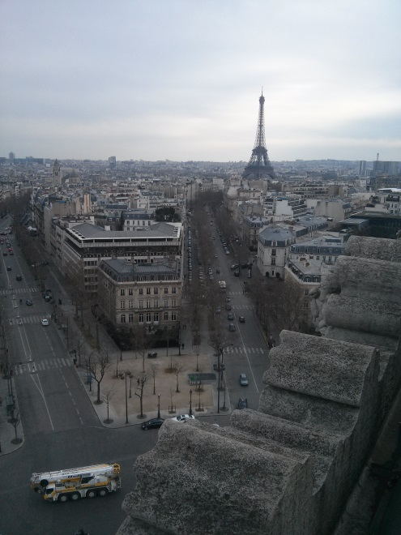

Finally, we walked back and went to dinner where I had a fantastic and rich chocolate mousse. I've really gotten to practice my French here, which surprises me. I thought Professor Lorenz would do all the talking (which is true) but there are still several occasions where she's not available and I have to speak for myself or answer people's questions. It's really coming in handy, and I'm glad for the chance to speak with French people and practice my skills. We have also had our fair share of adventure on this trip already. Before leaving, I wasn't allowed to check in to the flight because my name had been misspelled on the ticket, so we had to spend a long time trying to get that sorted out. On the plane ride over here, there was a medical situation and the flight attendant asked if there were any doctors on board, and the woman seated next to me (French) happened to be a pediatric surgeon so she went over. I talked to her and her friend (who turned out to be Italian so we spoke in Italian for a bit, which was fun) afterward and found out that there really was nothing wrong at all, and that someone had just felt very sick and fainted, but she was perfectly okay. And while we were riding the Metro to the Arc de Triomph, Erin and Meredith got closed out of the subway train and were left behind! We went to the next station as planned and caught up with them, but it was a definite adventure all day long.

Sunday, March 17 (Saint Patrick’s Day!)

Today was a very long day. Last night, Olivia woke me up in the middle of the night with her sleep talking, except I thought that it was already morning and she was telling me to wake up and that I had missed the alarm. I checked my phone and it said 7:35 so I said we had to get up. Olivia checked her phone too and saw the same thing and went to take a shower. I was very confused that it was still rather dark outside and that I was so tired so I looked at my watch it said 12:35. I was extremely confused. I was so delirious it took me a good five minutes to work out what had happened in my head. I had to check my watch, my phone, my watch again, the Paris time on my phone, try to do the math, and it just took a very long time. I then had to get up and tell Olivia (while she was in the shower) that it was actually midnight. She eventually got out of the shower and went to sleep without drying her hair, which actually worked out better because we could sleep in a bit because she didn't have to shower anymore, just dry her hair. We woke up again at the REAL 7:30 AM when my alarm went off and went to breakfast, which was yummy :)

After that, we headed first to the market at Clignancourt. When Professor Lorenz said we would have 2 hours to shop, I thought it would be way too long, but it turns out, it was just enough time. It was such a huge market and I liked it a lot more than I thought I would at first. We walked around and found some really interesting things in all the shops. I ended up buying some old postcards with writing on some of them and stamps, which was really neat, and a very small old key, all for 25 euros.

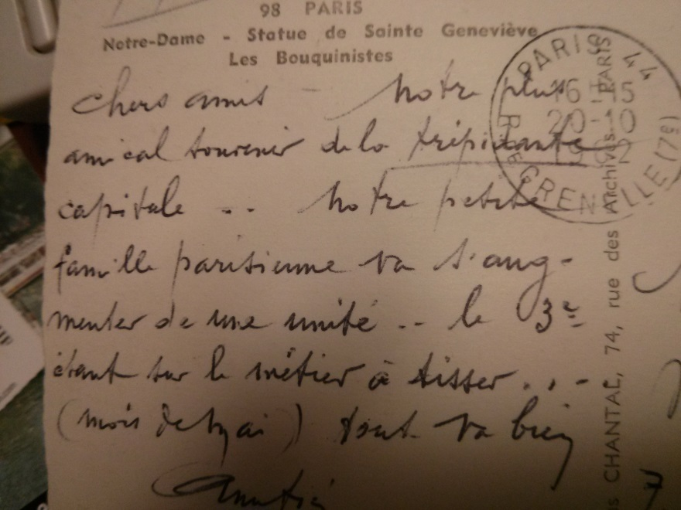

We went afterwards to the cité and saw Sainte Chappelle in the sun, which was beautiful, and Notre Dame, which was spectacular, saw the Roman ruins underneath, which were pretty cool and had really good interactive animated renditions of old Paris. We also went up the towers, which had so many steps! They never stopped! But the view at the top was spectacular. I saw two people come out of one of the bell towers through a little door that I don't think you were supposed to go through, but I didn't explore and now I kind of regret that.

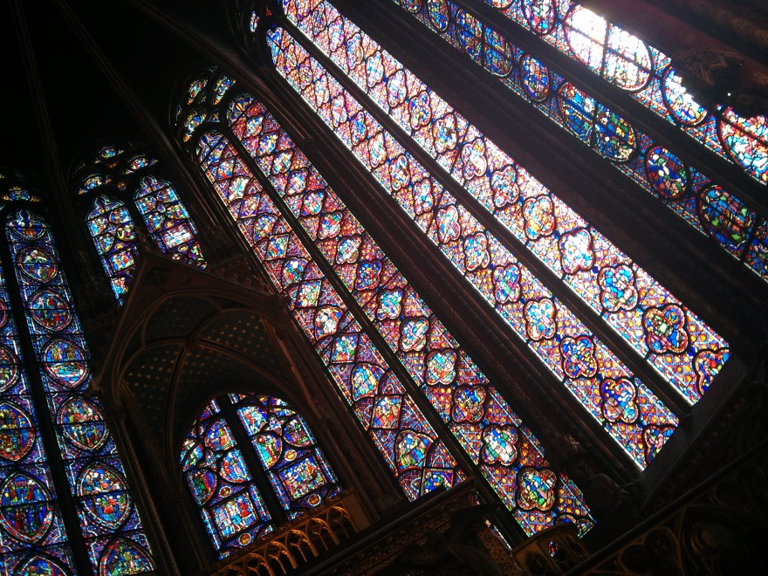

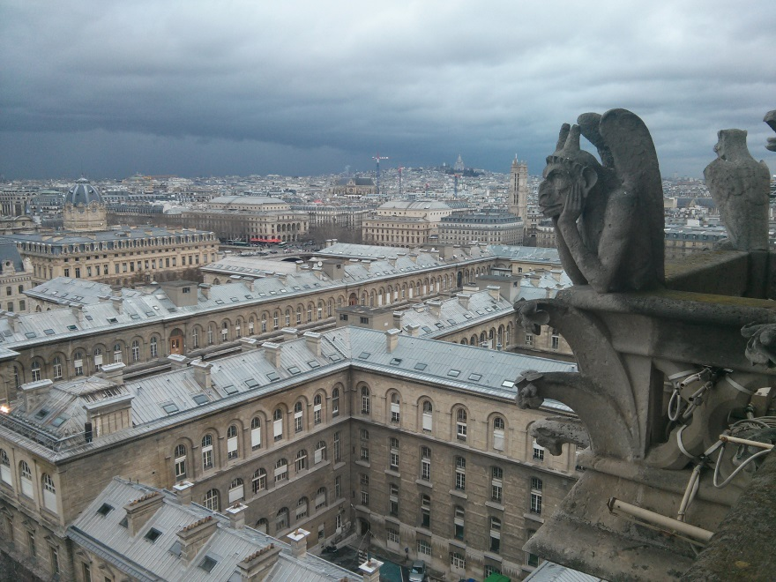

We stopped at a café for some food and I had a croque monsieur! Very interesting. I really liked it except for the burnt cheese on the edges.

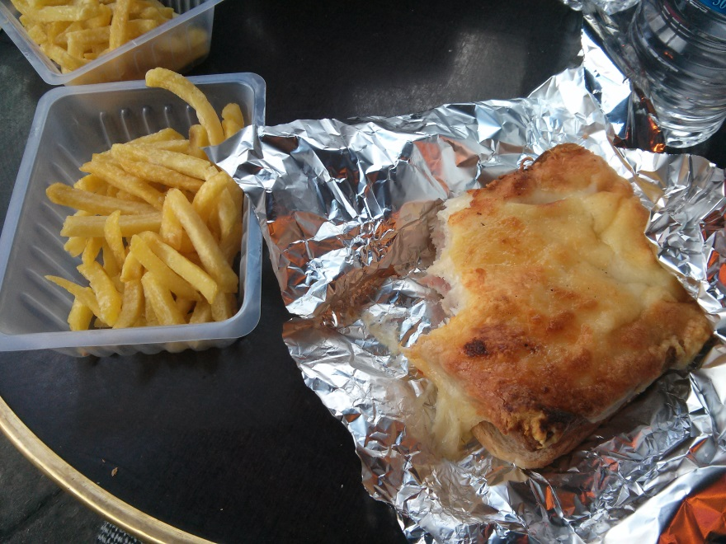

We also went souvenir shopping again and saw the Shakespeare Bookstore. We tried to go to the déportation monument, but it closed early for some reason. It rained a lot and it was also sunny. We saw so many rainbows! There was a rainbow at Notre Dame, and then we also saw a newly wed couple taking their wedding pictures in front of the cathedral. We went on a boat tour and saw another rainbow in front of the Eiffel Tower, so now I have pictures of rainbows in front of the two most famous Paris monuments! It actually hailed for a bit on that trip which was weird...

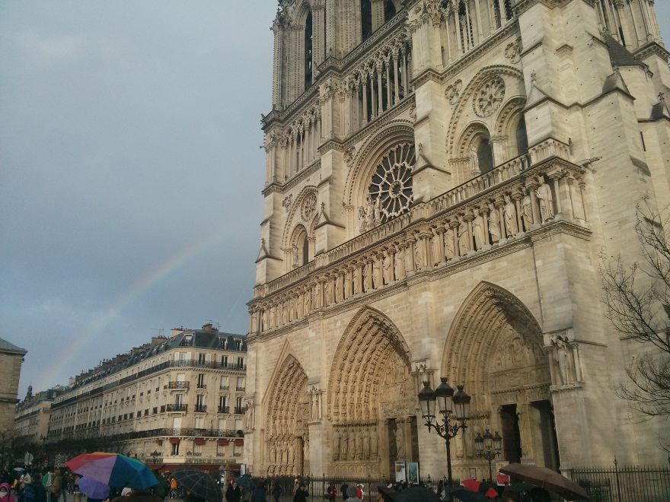

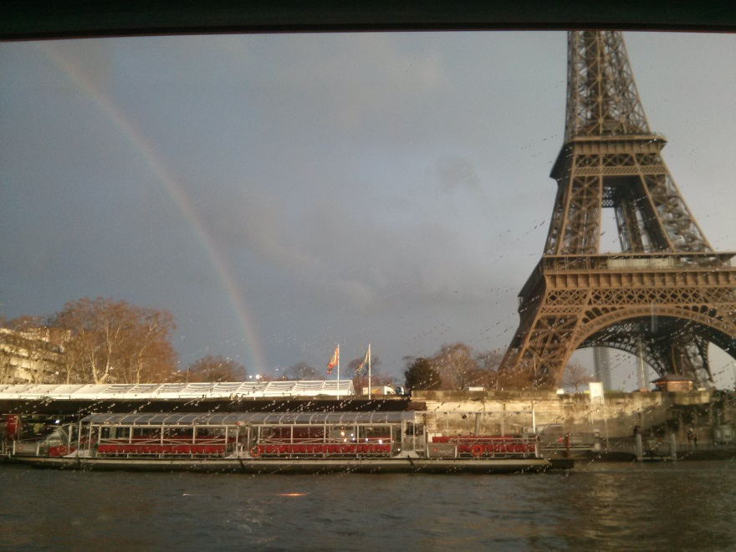

After the boat trip we went to dinner at a French place and had delicious food. I had mussels! So yummy. Then chicken with herbs (which, unfortunately was kind of dry), and finally crème caramele! Delicious. I loved it. And we had wine with dinner (rosé) which was fun and very good. Rhadika tried her first sip of alcoholic beverage ever and really liked it. She poured herself a glass and drank the whole thing!

Monday, March 18

Today was a very long day. After breakfast, we took the metro to the Louvre, which I liked a lot. We did a quick run through of all the highlights, and I was very surprised at how different the Mona Lisa seems in person. It's an image we've all seen a million times before, but for some reason, it just looks like a completely different painting on that wall by itself. Afterwards, we went off by ourselves to try and see the crown jewels. We were told it was going to be open in five minutes, but after waiting half an hour, we decided to leave and see the Napoleon apartments. There were some crown jewels on display there anyways, so it worked out. As it turns out, the Louvre is very difficult to navigate. We got lost a couple times and went in a complete circle at least once. But overall, I really wish I could have seen more and spent more time there. The group I was with wanted to go the gift shop and eat early, and I still wanted to see some exhibits if I could, but I didn't want to go off by myself and get lost, so I stayed with them. I ended up getting a museum guide in Italian for my mom, because she loves the Metropolitan in New York City, but she's never been to Paris to see the Louvre, and I'm sure she would love it. We had lunch at the Italian place in the cafeteria, and the server told me I spoke French very well :)

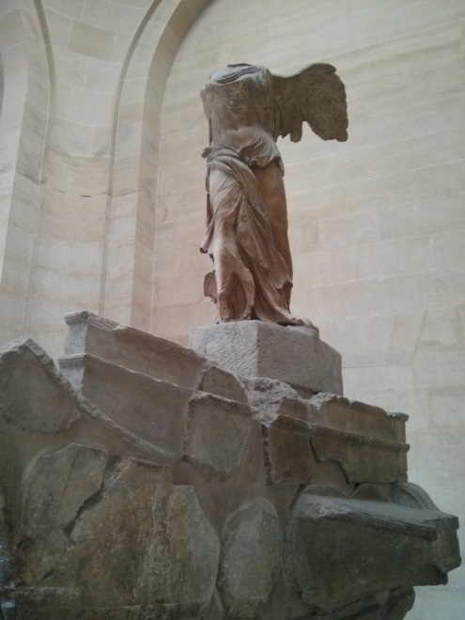

.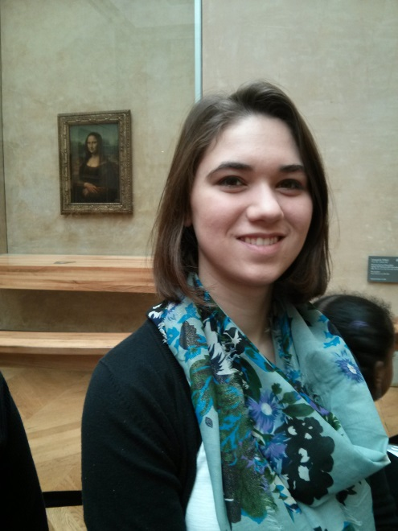

After lunch, we went to the Rue St. Honoré/Faubourg St. Honoré to see the very expensive shopping district and the Madeleine. It was very interesting walking around all the very expensive and ritzy shops. It reminded me a lot of Portofino and Old Oxford Street in London. We walked through Hermès and that was shocking. There were people buying 320 euro scarves and rich mothers buying their spoiled daughters expensive watch bands. It was almost like going to the zoo or a safari to me to see all the exotic animals in their native habitats... Michael stepped on a rug that was on sale for 14,500 euros. I went across the street afterwards to look at the Cartier windows with all of the sparkly diamonds... There were some really beautiful things there. We went to a tea shop afterwards, which looked very nice but I didn't get anything, and then we went to the Madeleine which was really spectacular. I was not expecting how grand it was on the inside. It just doesn't seem quite so big on the outside. Maybe because the outside is so linear and the inside has so many curves and domes. I'm not sure, but it was very unexpected. While we were walking around, just as Professor Lorenz was telling us about the hotels where celebrities usually stay on that street, we saw a crowd of teenage girls, and I thought “Justin Bieber must be in town.” Turns out he was.

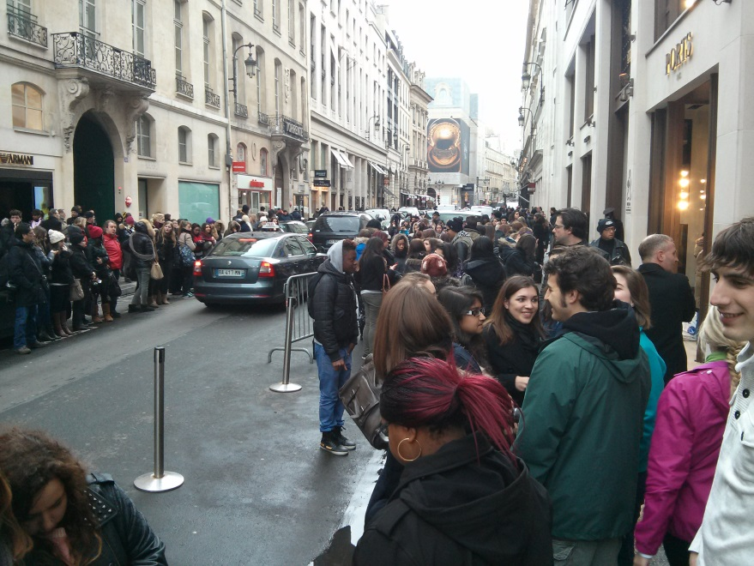

Next we went to the Tuilleries and the Orangerie to see the Monet waterlilies. I liked them. They weren't quite what I was expecting since I was picturing very large but also very tall paintings of the garden at Giverny with the bridge and everything. But I sat down and really looked at them for a bit with Lisa which was nice.

We came back to the hotel after that to relax a bit and I did a bit of relationship counseling over the phone... We'll see how it goes. Then some of us went to dinner and a very nice French restaurant and I had shredded carrots with vinaigrette, though I was expecting a balsamic vinaigrette, and I got something extremely acidic and a bit spicy... It almost tasted like sauerkraut, which was weird and I didn't like too much. I had a steak which tasted good but was very hard to cut and chew because of all the fat and tendons. And for dessert, Randi and I shared a chou chantilly which was sooo delicious. Chantilly is just a better version of whipped cream.

Tuesday, March 19

This morning we got up very early to go to Versailles. It made me very tired. We walked around the palace and saw the extraordinary wealth and extravagance of the royalty. You really get a sense of the ego of Louis XIV... After we lost Dr. Lorenz, we eavesdropped on various tour groups to learn about the palace. Between Michael and me, we could cover French, Italian, Spanish, and English tours. There was an Italian tour guide at one point who taught us about the hidden doors in the King's bedroom that led to the Queen's room and his lovers' rooms. I remembered learning about the hidden doors in Hohenschwangau that connected the King and Queen's room, but I didn't know he also had doors leading to his lovers' bedrooms. But it didn't really surprise me either. After we walked through the palace, we walked around the gardens and all the way up to the Petite Trianon. We walked right past it and didn't even realize. And by that time we had to go back for lunch so we didn't even bother to check if it was open.

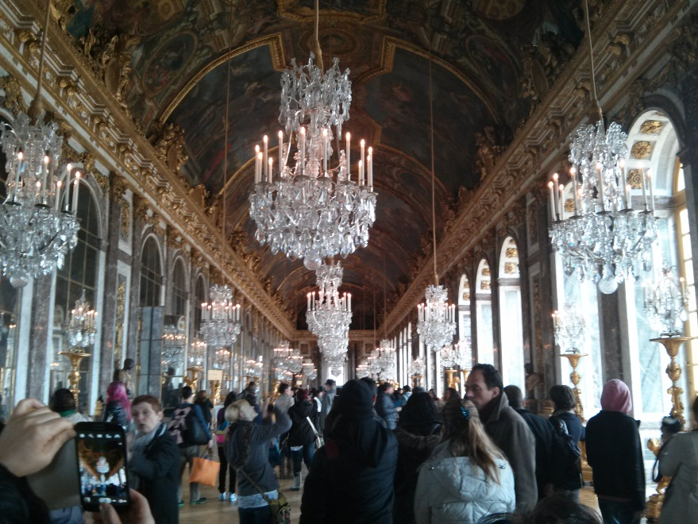

After lunch, we went back to Paris to see the Eiffel Tower! The sky cleared up for a bit and we had sunshine and blue skies with white puffy clouds just in time for our touristy pictures. We went all the way up to the top, which did make me pretty nervous, I have to admit, but once I was at the top, I felt completely fine. It was actually more nerve-wracking to be at the second level than at the top. We found free wi-fi at the top of the tower (go figure) and tweeted some pictures of us at the top to UC Honors and snapchatted friends, so that was fun.

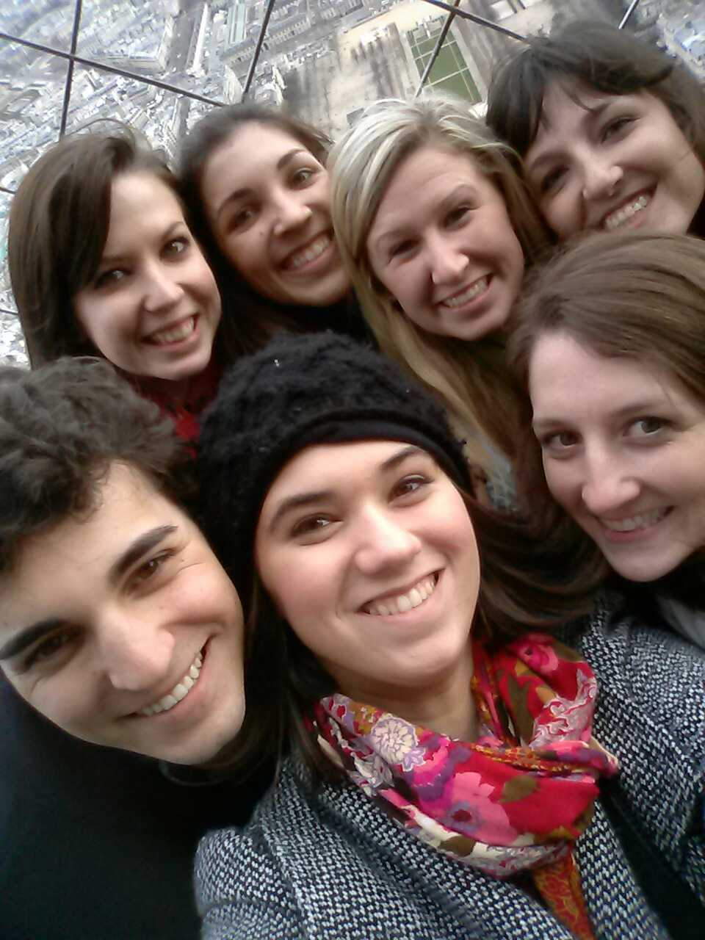

Afterwards, we tried to make our way to the Invalides to see Napoleon's tomb, but it closed early. Olivia's theory is that it closed early for French Veteran's Day. Maybe there was something happening there since it's still a veteran's hospital. But I was disappointed nonetheless because I was really looking forward to seeing it. Hopefully we'll be able to go back tomorrow or later in the week.

We thought the Rodin museum was closed at this point, but we went anyways, and it turned out that we had half an hour to walk around and visit. I saw the Thinker and some other interesting statues in the garden. It rained a lot, though. I got very wet. I took some pictures for my mom because she loves Rodin sculptures.

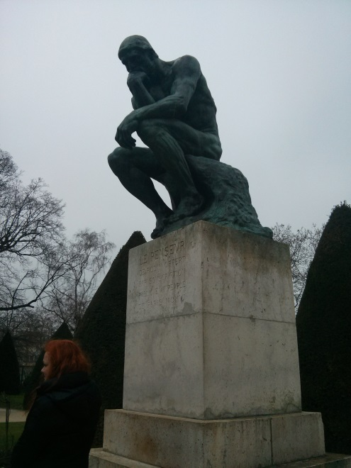

We went to dinner back in the student district and had couscous. I had the vegetarian couscous and it was delicious. We stopped for a crèpe afterwards, but it wasn't as good as the one I had in the flea market on Sunday, sadly. Erin really wanted to see the twinkling Eiffel Tower before heading back to the hotel so a bunch of us went with her to the Arc de Triomphe to watch from the top. It was really an amazing sight. I'm glad I went. The stairs were completely worth climbing all over again. The giant French flag was also hanging underneath because of the Veteran's Day activities, so that was really cool to see.

Wednesday, March 20

This morning, I woke up to an adventure. Olivia came back at 8 in the morning and told me about her trip to the hospital to get stitches and that caused some drama and gossip throughout the day. But after breakfast, we went to a fashion exhibit that was really cool and then to the Centre Pompidou to see 20th century art. I walked around with Molly, Lisa, and Randi. I really liked some of the pieces, like the chain link fence that was reworked and the computational algorithm art and the interactive art, but some of the exhibits were just a little too weird for my taste. I really didn't understand them and they were just too out there... Unfortunately, we didn't make it to the next floor of the museum, so we missed the Kandinskys and Picassos and the more famous artists. After the museum, we had a sandwich and a crèpe from a street vendor that were both very good and headed out to the Basilique Saint Denis.

The Basilica is absolutely amazing. I really liked it--a lot more than Notre Dame. I'm not sure why, but it really impressed me much more. I really loved the stained glass windows the most. The crypt was really neat too. I discovered that the French like to remove body parts from their royalty to be buried and spread around to different places sometimes. They had Louis XVII's heart on display in a glass jar. As usual, I lit a candle for Dino and Nonna Mia. The candles in these churches have unfortunately been more expensive than I'm used to...

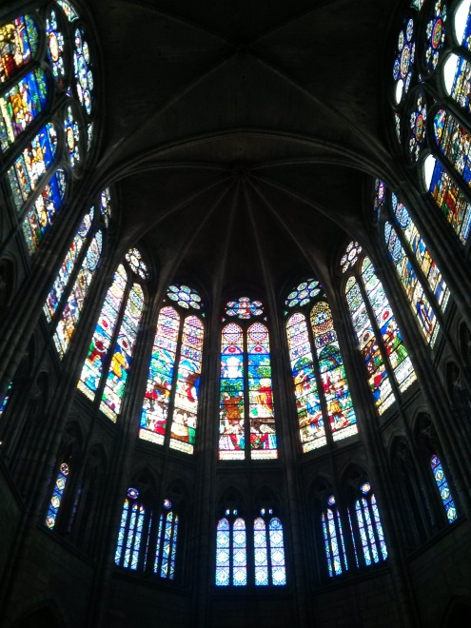

We went back to the hotel and then Molly, Radhika, Mykia, Sam, and I went to McDonald's because we were very hungry and didn't feel like trying to pick a place to eat. The food was terrible and the Fanta was fake, but it filled my stomach and wasn't terribly expensive. After that, we were on our way to see the Eiffel Tower at night. We took the subway by ourselves for the first time (at least for me) and made it there and back without any problems. We saw the tower sparkle at 9 PM from the outside and then went up the tower to see it twinkle again at 10 PM. We went all the way to the top again to see Paris at night and it was amazing. Radhika and I went down the stairs a little bit to be inside the tower as it twinkled, and then went back up to watch it twinkle from the second level all the way to the top. It was definitely a magical sight. Strangely enough, the tower had a very high density of Italians. I swear, 9/10 on the tower were Italian. It was weird.

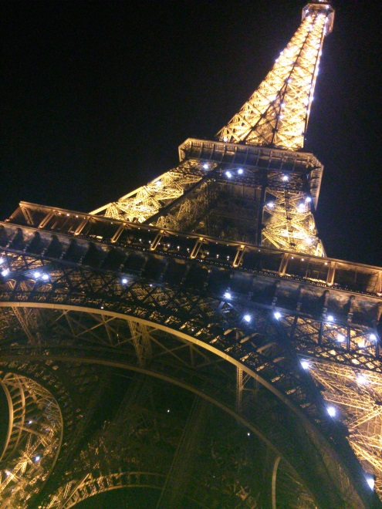

Thursday, March 21

This morning after breakfast, we went straight to the Opéra Garnier to see the opera house and do some shopping at the Galeries Lafayette. The opera house was amazing. I'm really glad I decided to go inside instead of going straight to the grands magasins. The grand staircase and the foyer were definitely the most impressive... far more than the actual theater in my opinion, although the Chagal ceiling was pretty cool. We were all pretty big Phantom of the Opera fans so we headed straight towards Box no. 5 and there actually was a plaque saying "Loge du fantôme de l'opéra" on the door and there was a small window so we could see through! I really want to read the actual book now. Afterwards, we went to the Galeries Lafayette to see all the expensive stores and Radhika, Lisa, and I went all the way to the top to look out at the city. It was a much needed break.

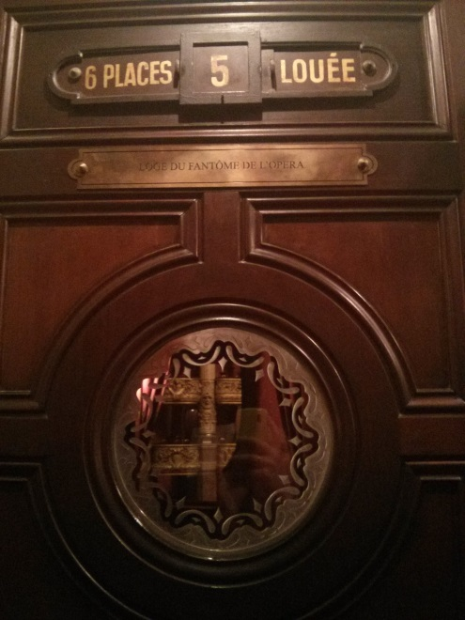

On the way to the Cluny Museum, there were people handing out free chocolate and cookie type things that were really yummy so I got two :) I was hungry because we hadn't had lunch yet. The Cluny Museum was very interesting, with all the stained glass windows that we saw missing from Sainte Chappelle and the famous tapestries of the lady with the unicorn. I tried to listen in on the French class but it was difficult and I was sleepy, so I read from the card instead. It is pretty impressive that all six tapestries have managed to stay together since their commission.

After the Cluny museum, we went around the Sorbonne and had a very good lunch for only 5 euros. We walked so much today... I was exhausted. We walked to Saint Germain des Prés and that was a very nice church. Someone started playing the organ while we were there which was amazing, and I wish we could have stayed a little bit longer to listen and rest, but we had to get going. We kept walking to the Orsay museum, and there we saw a really creepy exhibit on dark romanticism, which was interesting, but not really my taste. We didn't have much time, so we went straight to the masterpieces upstairs and that really was incredible. If I hadn't been so exhausted and in pain, I would have stayed much longer. We ended up not going on the guided tour, which I was very glad for only because of the fact that I was miserable, but if I were more awake, I would have liked to get more detailed information about some of these really important pieces of art.

We took the subway back to Ternes around 7:30 and picked up some food from the Monoprix which was actually very good and then went back to the room to eat. Sam came down to our room and we all hung out together and soaked our feet in hot water and played Ruzzle on our phones. It was a nice, relaxing evening.
Friday, March 22

We spent our last day in Paris doing all the things that didn't require a museum pass... We started out by going up to Père Lachaise cemetery before going up to Montmartre to see Sacré Coeur. The cemetery was huge and very crowded, and I had pictured it being more of a park, but I was wrong. I saw some very interesting graves though.

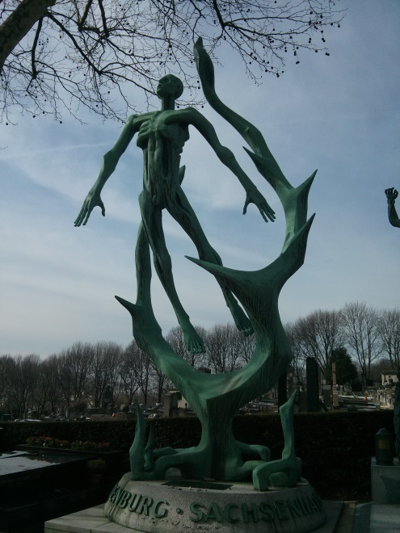

On the way up, Erin, Lisa, and I stopped for lunch at this little street café that turned out to be really good! I had a very reasonably priced, filling meal. I finally had quiche in Paris! I had a goat cheese and tomato quiche with pain au chocolat for dessert and orangina to drink. The pain au chocolat was the best I have had during the entire trip, which would arguably make it the best one ever. The chocolate inside was melted. MMmm. So good. Then we all headed up the hill to see the basilica, which was beautiful, but not nearly as white and as clean as I had pictured it. We were told it was self-cleaning stone, but it didn't look all that clean to me up close. The inside of the church was beautiful, as expected, but we weren't allowed to take any photographs. I lit another candle like I always do for Dino and Nonna Mia. As we left, we saw many people trying to tie bracelets and demand money. Luckily, we didn't get caught by them, but we did stop to watch other people, which was pretty funny.

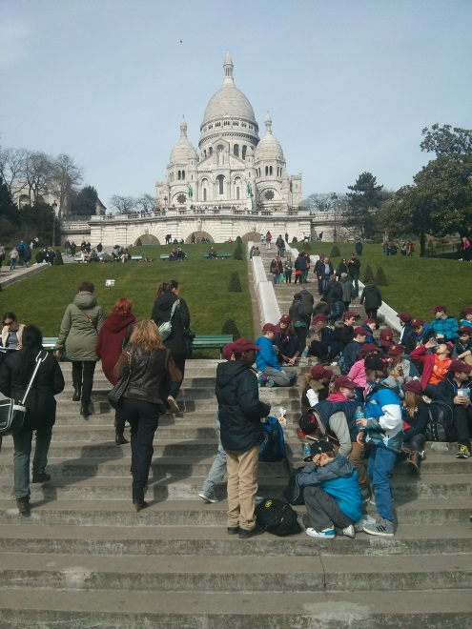

After Montmartre, we headed down towards the catacombs! I'm glad I went, but it's not something I'd like to do again. It was creepy and I didn't like being down there. Once was enough.

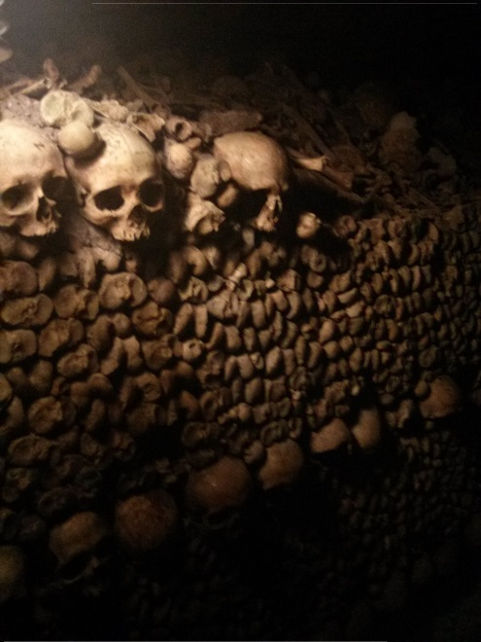

After that, we walked around Montparnasse and did some shopping. I tried to get Patrick to buy a pair of shoes, but he didn't really like them, so we went to fnac to meet up with everyone and started playing with all the gadgets and toys. I apologized for being a nerd, but he just laughed and said "You're an engineer. I would expect nothing less." He had a point. One of the iPads had Tiny Wings installed (which is my favorite app ever but isn't available for Android so I haven't played it in a long time) so I was very excited to play that again.

We lost Sam for a bit in the shoe store, but we finally found her and then some of us headed back to the hotel to start packing. I tried, but didn't feel like starting because we were about to go to dinner, so I didn't get anything done. For dinner, we went to this nice café near the hotel and we had fresh pasta! I originally asked for spaghetti carbonara, but the chef mixed up all the pastas, so I ended up with tagliatelle carbonara, which I was perfectly okay with because I was debating between that and spaghetti in the first place. It was delicious! Probably the best meal I had in Paris. It was also Italian food and therefore the most familiar to me, so that probably had something to do with it... but it really was well prepared and tasty. For dessert, I had millefoglia which was so good! Such a great meal. I was really pleased.

Before going back to the hotel once and for all, Erin, Patrick, and I went to the Monoprix to pick up some chocolate for the trip home. I helped Erin pick out European candies to bring back while I got really excited over all of my favorite chocolates that I can't find in the US. I found ChocoMoos, which I only ever had in Berlin, but they're my favorite cookies, so I brought a box of those back home, and then I brought some Kinder eggs for my brother with Asterix and Obelix toys inside, and a large Kinder egg for my whole family to open for Easter. Unfortunately, those are contraband, but I think I'll make it through customs okay...

We finally went back to the hotel and I spent the rest of the night trying to pack up all of my things and be ready to go to the airport bright and early in the morning.

