Irini Sfyris
Professor Russell
Urbanism: Observing the City
5 June 2012
Corner, Cullen, and Hiss: Mapping Cincinnati through the Eyes of a Flying Pig
Before you can understand a city, you must first observe it. These observations might lead to a theory to explain the observations. Or it might work the other way around: you learn about theory, and then you set out to use it as a basis for observation. In this seminar, we aimed to do just that. I used the work of James Corner, Gordon Cullen, and Tony Hiss to support my observations of Cincinnati to help create a visual representation of my experiences.
James Corner, a Manchester-born landscape architect, wrote an article on the definition of mapping and many ways to do it. His main argument is that mapping is inherently different from tracing. According to Corner, tracing is “what is” while mapping is “what is and what is not yet” (214), meaning a tracing is simply a representation of what exists, while a map should create new perspectives and ways of viewing things that exist as well as represent them. And the things that exist are “more than just the physical attributes of terrain (topography, rivers, roads, buildings) but [include] … natural processes such as wind and sun; historical events and local stories; economic and legislative conditions; even political interests, regulatory mechanisms and programmatic structures” (Corner 214). Corner’s solution is to look to more abstract methods of representation, such as drift. Drift is a technique that resulted from the Situationists in Europe. Guy Debord was one important theorist of this group. He made his own maps that he called “psycho-geographic guides” by simply wandering aimlessly around the city of Paris, through the streets and alleyways, just going wherever he felt like it and taking notice of things he found important. He recorded these wanderings, and the result “reflected subjective, street-level desires and perceptions” as opposed to a bird’s-eye-view of the traditional street map (Corner 231). Debord’s work was useful in creating my own map of Cincinnati because the entire marathon route was simply too long for me to tackle in such a short amount of time. Instead, I focused on four areas of the course and I represented them in Debord’s manner of connecting pieces of a map with arrows indicating the direction of the route taken to get there. Though Debord was discussed in Corner’s article, they are two different theories. Corner is all about representation and all the different techniques. Debord was trying to deconstruct preconceived notions of a place. He wanted to tackle the traditional, “scripted” routine of life and turn it around and make it “unscripted” by wandering and giving significance to things and places that caught his eye. Though the Flying Pig Marathon is a highly scripted course, I made it my own unscripted project by using my personal opinions to influence my choice if location. By essentially taking them out of the context of a race, the locations become much less scripted. I also actually wandered around myself and deviated from the course in order to gain a better understanding of the character of each location. In this way, I got more than just a literal representation of my surroundings; I also got my own subjective views, making this map more personal than anything I could have bought in a store.
Corner also talks about a concept called layering. This involves literally layering different kinds of maps to create a new, multidimensional map that can say more than any one individual layer. The end result is greater than the sum of its parts, because you can start seeing connections between layers. The advantage to a layered map as opposed to the traditional plan is that it is open to interpretation and allows for a lot more freedom. As Corner explains, “[j]ust as upon the gymnasium floor, almost anything can happen; the layered structure provides little restraint or imposition” (236). This technique was particularly useful in my project because I wanted to create this kind of multidimensional representation of my route through Cincinnati, showing things like my impressions of a place, descriptive adjectives, or things that particularly stood out to me.
As part of my multidimensional map, I wanted to include some sort of visual representation. I really liked the work of Gordon Cullen and knew that I wanted to use something like it for my project before I even knew what the project was. This method of representation was called “Serial Vision” and is actually a fairly simple concept. It “consists of a series of sketch perspectives arranged in a sequence, as one would wander along a given route. The sequence is accompanied by a plan, indicating the points along the path where the perspectives are taken from” (Lucas 1). The point of sketching for him could be to emphasize things he thought were important and exclude things he thought weren’t. I used something similar to his technique, except that I used photographs because to me, that’s better than deciding what stays or goes in the sketch; everything is included and each and every person who looks at the pictures can interpret the path for themselves. It is a more complete representation because almost everything is included (depending on the resolution of your camera). It is similar to the “Street View” on Google Maps, adding yet another dimension to an otherwise two-dimensional map.
Finally I looked at the work of Tony Hiss. Hiss is a journalist whose writing is very accessible to the public. He fits well within one of Vernez-Moudon’s categories: Place Studies, and in fact, she cites him as an example of work in this movement. Hiss is primarily focused on the experiential, as opposed to Corner who focuses on the objective and what can be observed. Cullen is also focused on the experiential, however, he is extremely visual while Hiss prefers to describe and create a metal image, not a literal photograph. While Cullen has a relatively accurate representation that allows for individual interpretation, Hiss provides a method to convey an extremely personal experience. His big idea was “simultaneous perception” where one allows all of their feelings and senses to interfere with their interpretation of a place. In his essay describing his own experience through Grand Central Station in New York, he was able to describe not only the visual aspects of his surroundings, but also his own perspective on the movement of people around him and his own part in the choreography of the scene. He talks about being caught up in the crowd of people and being moved almost against his will, as well as the sound of the many voices humming throughout the station. This method of description is valuable not only for its visual cues, but also the phenomenological ones. It gives insight to both the look and feel of a place. I used Hiss’s techniques to write down many descriptive words about each place, as well as comment on my thoughts and feelings in each place.
I think it’s worth mentioning that I did not go to each location and write down my observations in the present time because what’s important is the perception you take away with you after you leave a place. Your impression is based on what you remember about a place when you’re not actually there. For most of the places I visited (except Covington), I had been there several times before and already had a perception about the locations, which actually helped with the project because, after all, it was entirely about my own experience with the place and I had a broader range of experiences to base these impressions off of. For example, when I visited O’Bryonville specifically for this project to take pictures, I went late on a Sunday afternoon when hardly anyone was out and all the shops were closing. If I hadn’t known any better, I probably would’ve thought that the area was too quiet and possibly even boring. Instead, I knew that traffic can get crazy and people can be everywhere, walking through shops, parking their cars, driving home, etc. I left with the impression that O’Bryonville has life and energy, even if it was quiet for just a moment, when that singular experience should have told me otherwise. So I used these past experiences to come up with descriptions and think of things that really made an impression and that is what I chose to write down in words. Some of the map merely has single words or short phrases, while other parts have complete sentences and thoughts.
The contribution of these theorists to my project all fit within a wider scheme, which is the mode and concentrations of my inquiry, as defined by Anne Vernez-Moudon. My approach to this project was purely phenomenological. She describes it as an approach that “projects a holistic view of the world, everything being related to everything, and whose practice depends entirely on the researcher’s total experience of an event” (Vernez-Moudon 335). It’s highly qualitative as I tried to stay away from counting or measuring anything. I just wanted to document an experience. I focused my observations on two concentrations of inquiry: picturesque and place studies. Picturesque studies were defined as “running personal commentaries of the attributes of the physical environment… Object oriented, these words emphasize the visual aspect of the environment, which is seen as a stage set or a prop of human action” (338). I used the work of Gordon Cullen as the basis for my picturesque studies. Place studies, on the other hand, are “how people perceive, feel, use, and interact with their surroundings” (333). This is where the work of Tony Hiss came into play in my project. Place studies are almost inherent to the nature of my project. I wanted to document an experience which includes not only visual cues but also my thoughts and reactions to the environment. Instead of studying how people in general see and interact with their surroundings, it was about how I personally did all of these things. I don’t think I’m qualified to quantitatively observe other people, document my observations, and come up with a conclusion. I have never taken any statistics courses so any studies I would do would probably not be valid, and there are just too many factors that influence how a person will perceive their environment, such as culture, past experiences, and any number of things I couldn’t possibly hope to control for, especially in such a short amount of time. My samples would not be nearly large or broad enough and there is just so much that I could not accomplish if I took a more positivistic approach.
My project itself was to look at Cincinnati through the lens of the course of the Flying Pig Marathon. I wanted to see how the course portrayed the city. In order to complete this project, I selected four areas that I thought were significant or important for some reason to the course, the city, or to me. I chose to look at Downtown, Newport and Covington, Eden Park, and O’Bryonville because I thought that each area had an important purpose that made it important for the course to run through.
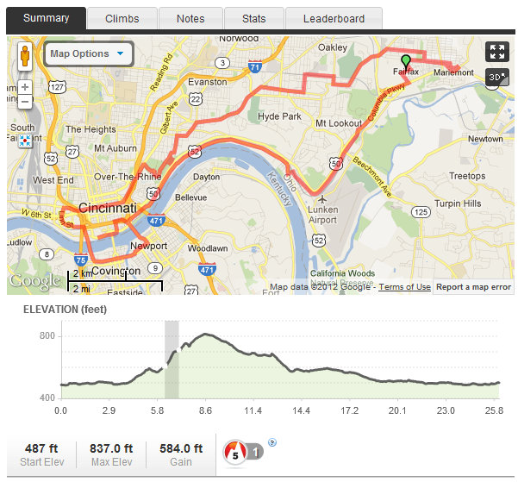
(FlyingPigMarathon.com)
Downtown seemed like an obvious choice because it is the center of the city with important civic duties such as housing the local government, as well as being a major business and entertainment district. It’s filled with restaurants and shops as well as major theaters, like the Aronoff Center and the Taft Theater. Cincinnati is actually surprisingly supportive of the fine arts so major productions and tours come through the downtown area, making it a pretty significant area as far as I’m concerned.
Next I wanted to look at Newport and Covington because I found it very interesting that a course that prides itself on being so very “Cincinnati” would include areas in an entirely different state. Newport I could understand because it serves as a big entertainment district for many Cincinnatians, with the aquarium, the movie theater, and all the restaurants, as well as the beautiful vista of the Cincinnati skyline, but Covington was another matter. I thought it was very strange that they chose to pretty much skip Newport on the Levee and go straight through Covington instead.
Third, I chose to concentrate on Eden Park. Cincinnati is riddled with beautiful parks, but Eden Park might be the most important of them all. It’s very large, overlooks the river, and contains important cultural landmarks, namely, the Krohn Conservatory, the art museum, and Playhouse in the Park. It’s a peaceful and quiet retreat in the middle of a dense, urban environment, almost like our own Central Park. It sits next to the quaint area of Mount Adams but is only moments away from the busy downtown area.
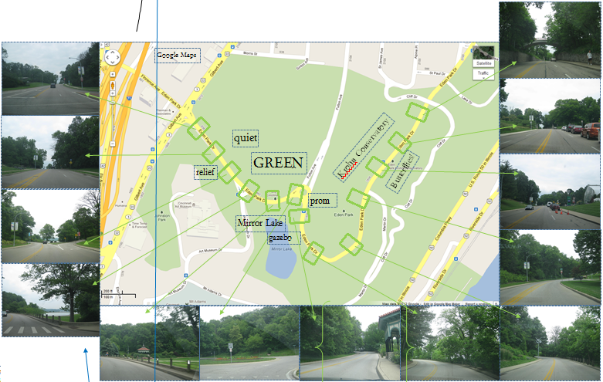
(The map in the background was provided by Google Maps but all other images were taken by me personally. This is true for all other images in this paper).
Finally, I chose O’Bryonville because of its suburban qualities. Granted, it’s a very nice suburb, with large beautiful houses and private streets, but it’s a great example of a small community within the bigger city of Cincinnati. O’Bryonville has a city center that is reminiscent of a small-town Main Street, though this main street is actually extremely large and moves an extraordinary amount of traffic every day. It reminds me of home, which is probably why I like it so much, because I grew up in a small, relatively wealthy neighborhood with the stereotypical Main Street, except O’Bryonville has more interesting shopping. There are no big chain coffee shops or fast food stops. They are mostly small boutiques, selling everything from homemade jewelry and art to fair trade items from around the world to cupcakes. The place lives and breathes money. The jewelry isn’t just your local arts and crafts hobby store selling ten dollar earrings; they have high quality pieces selling for hundreds of dollars. And the bakery has a posh café attached, where you can reserve a spot for afternoon tea and they serve you finger-food-sized cucumber sandwiches and sugar cookies.
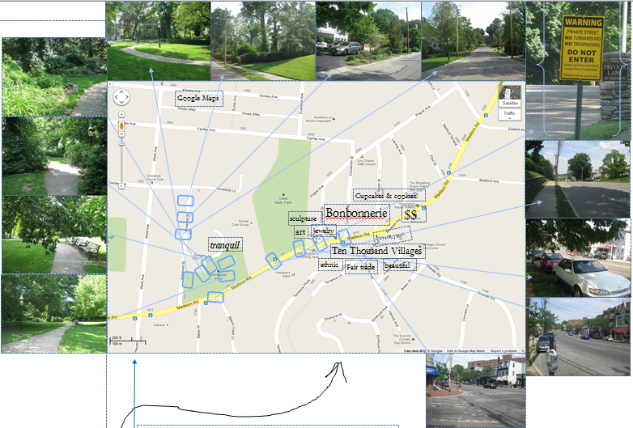
After visiting each of these places, I tried to express these qualities about them in a map. I “stitched” together pieces of maps featuring each of the four locations using arrows, just like Guy Debord, and on each map I placed several pictures along the route I took, as well as several descriptive words and phrases floating around where I thought them. Around the map sections on the poster version are blown up pictures of the ones along the route in order so that the reader can get see their content better. All of this was to achieve the layering effect described earlier.
My methods of observation unfortunately were not very technical. I went when I could get a ride somewhere and when I had free time, which was usually on a Wednesday afternoon (I finish classes at noon on Wednesday, leaving plenty of time for me to go out), though I did go on a weekend once. All of the times I went were pretty low traffic. I visited downtown, Covington, and Eden Park on Wednesdays during business hours and I saw O’Bryonville on a late Sunday afternoon. I walked down the streets while taking pictures, sometimes wandering around to explore the area and get a sense of character.
In downtown, I made several observations about my experience. Right when you enter the commercial district heading east on Seventh Street, you pass City Hall and some large, boring brown buildings, but if you look to your left on Plum Street, there is the Plum Street Temple where my brother once went for a friend’s Bar Mitzvah (which is how I first became interested in the building because it is really beautiful) and right across the street is an equally beautiful church (Catholic probably because it’s so ornate). For some reason, seeing these two religious buildings juxtaposed always makes me feel just a little bit better about the world because historically, Christianity and Judaism have clashed, and the fact that they sit across from one another in presumable peace restores my faith in humanity just a bit if only for a moment. As I continued down Seventh Street, I got more and more stressed because commotion and traffic stresses me out. Also, I was driving because that was the street I had taken just to get into downtown and one-way streets make me very, very nervous. I suppose that because I come from a small suburb with very little traffic in comparison, downtown honestly scares me. So I can’t help but feel anxious there. But then I persevered and continued down the street and was rewarded by finding the Aronoff Center to my right—one of my favorite places in the city because of all the fantastic shows I’ve seen there. I just get excited whenever I see it because it brings back memories and happy feelings from being there.
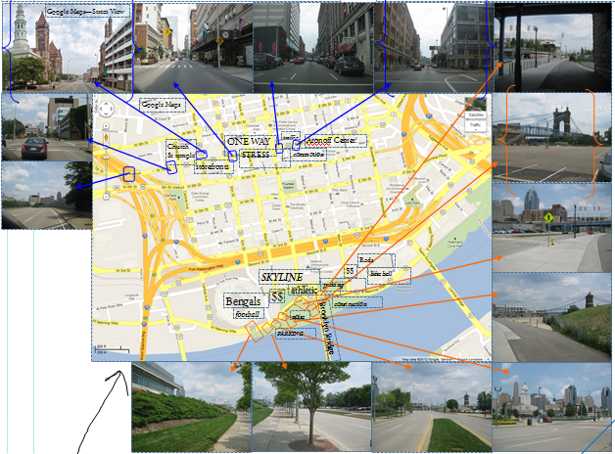
(The picture in the upper left-hand corner of the church and temple was provided by Google Maps – Street View).
Covington mostly just confused me. I went there on a relatively lousy day, weather-wise, so that definitely didn’t help. Everything just looked pretty bleak and generally not very interesting. There were some shops and businesses but everything about the place was totally lacking energy. It just seemed so dreary that I honestly couldn’t wait to leave. I don’t understand why the course doesn’t just go around Newport on the Levee, whose restaurants and entertainment options are what draw Cincinnatians across the river into Kentucky.
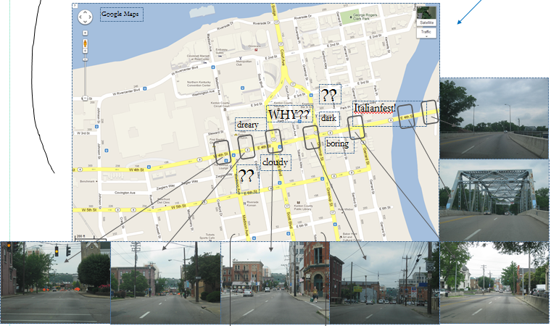
As for my observations about Eden Park and O’Bryonville, they were previously discussed in the description of why I chose the places I did. The fact that I liked them so much already made them significant to me, earning them their place in this project.
I did make one observation about where the course specifically did not go: it ventures nowhere near the west side of Cincinnati (defined by the division created by I-75), which is traditionally the less privileged and less glamorous part of the city. But it is still half of the city and very important because of that. So I was very surprised to see how much the course really avoided that area.
I had a lot of limitations simply because I was following a predetermined course. If I had been new to the city, it would have been hard to get a good understanding of each area because the course strives for big roads that can accommodate huge throngs of people running the marathon, which sometimes means sacrificing significant landmarks. For example, in downtown, the course runs down Seventh Street, completely missing things like Fountain Square, which is probably the single most iconic place in Cincinnati, and important cultural landmarks like Underground Railroad Museum or the Contemporary Art Museum and the Taft Theatre. Also, the fact that the course was way too large for me to try and walk or drive through all of it forced me to choose a few locations on which to concentrate.
There were several externalities that affected my impression of each of the locations. In downtown, my upbringing and nervousness had a negative impact, while my past memories of the Aronoff Center had a positive effect. In Covington, I might’ve had a completely different impression if the sun were shining (though I still think it wouldn’t have been that great because I didn’t have any previous memories or feelings about the place that would’ve created a positive impression). I had a great time in Eden Park mostly due to past memories and future expectations. In the past, I have gone to the park with my family and friends. One of my best friends lives right across from the Art Museum so I’m always reminded of being with her when I go through the area. We walked over Mirror Lake when it was completely iced over and her brother was being silly and accidentally stuck his foot through the ice and got all wet, which was really funny. And now I can’t walk past the gazebo without thinking of my senior prom. My friends and I all took our pictures there before heading to the dance itself, which was being held in the Cincinnati Club. It was a night of fun and excitement. After all, who can ever forget their senior prom? Also, the day of my official observations, I was planning on seeing the Butterfly Show, which is one of my favorite events in Cincinnati, and I was really excited to see it. And in O’Bryonville, I have spent a lot of time there with family and friends as well. I’ve gone to afternoon tea with my mom at the Bonbonnerie and felt really fancy while eating cucumber sandwiches and delicious cookies, not to mention I just love that bakery because their desserts are to die for. And I’ve gone shopping with my friends in Ten Thousand Villages. I love that everything is fair trade and beautiful. I went with a Philippina friend of mine and we bought a really nice wind chime (from the Philippines) for my mom’s birthday, and she loved it when I gave it to her.
Overall, my observations led me to the conclusion that the Marathon does not aim to accurately depict the city and its people—it only tries to highlight the parts of Cincinnati it wants to show off to the country. Just as a highlighter emphasizes the parts of a text to which they want to bring attention, the Flying Pig Marathon “highlights” and showcases the parts of the city it wants everyone to see and remember. But since runners on the course really don’t notice the scenery around them too much as they’re much more concerned with the changes in elevation and simply making it to the finish line, this special attention must be directed at spectators and the media. Spectators don’t spend a lot of time moving around, and might have only come to cheer on a specific individual or team. While waiting for those people to go by, they inevitably look around and react to their environment. If the surroundings aren’t pleasant, people would not be inclined to attend the race. Any media covering the race will capture the same picturesque surroundings in the background of their photographs or videos, which would inevitably create a positive impression of Cincinnati in the minds of any viewers. In fact, when answering a survey about my opinions on the race as a volunteer, they specifically ask if the race improved my opinion of the city.
As a result of my observations, I came up with a proposal for an improvement that could be made. Cincinnati could really benefit from redesigning the course to bring attention to some of the more neglected areas of the city. Hyde Park already has enough money and attention, so why not direct the race to places on the West Side? It would bring media attention and provide opportunities to local businesses for direct advertisement and possibly even sales, with all the spectators walking around. Though this would be in conflict with the primary goal of the race to portray Cincinnati as a beautiful and rich area, it would inevitably benefit the city as a whole as well as show Cincinnati how it really is.

Works Cited
Corner, James. "The Agency of Mapping: Speculation, Critique and Invention." Mappings. Ed.
Denis E. Cosgrove. London: Reaktion, 1999. 231-52. Print.
Lucas, Raymond P. "Gordon Cullen's Serial Vision and Picturesque Urban Design
Representations." Web.me.com. Mar. 2009. Web. 30 Apr. 2012. <http://web.me.com/raymond.p.lucas/Jakarta/Review_files/Cullen.pdf>.
"Marathon Course." Map. FlyingPigMarathon.com. Cincinnati Marathon. Web. 30 May 2012.
<http://www.flyingpigmarathon.com/race_information/course/>.
Vernez-Moudon, Anne. "A Catholic Approach to Organizing What Urban Designers Should
Know." Journal of Planning Literature: 331-49. Print.

